**CLOUDS, SERVICES, SERVERS**

**What does it do? What is the state of the art of this new technology? What can be done now? What is likely to be able to do be done soon (say in the next 3 years)?**

Clouds, services, servers provide us with an array of computer services ranging from software applications, data, networks for individuals or businesses. It provides the connection and access using technology through the internet to sustain, maintain, host and share the use of data.

This technology is the preferred method to move away from individually physical hosted servers to cloud based which has many advantages such as:

* Pricing – pay as you go pricing model for businesses requiring services across servers, platforms, technology, data storage, etc. No need for any upfront costs or complexity to maintaining and owning their own infrastructure and reduces hardware costs.
* Stability – highly reliable, scalable and agile distribution systems
* Speed – Fast, increased broadband
* Security – Cybercrime and Cybersecurity is a major factor as this requires high cost to monitor. Cloud security sustainability through data protection and authentication, to maintain highest control and reduce risk.
* Saves time and resources – Increases productivity, flexible and reduction, less need of in-house IT staff

There are 3 main categories of cloud computing through the servers:

1. IaaS: "Infrastructure as a Service" which allows organizations to operate and maintain all their servers, network, infrastructure, data storage and operating systems, which is a complete solution to a business's needs. This allows for growth an cater for developments and future requirements. Examples are Microsoft Azure and Amazon Web Services.
2. PaaS: "Platform as a Service" provides developers with cloud-based platforms to utilize to create customized software applications to store and build their creations. Examples are Heroku & Windows Azure
3. SaaS: "Software as a Service" are cloud based software that is available online on a subscription basis that doesn't require any downloads to your machine and can be shared collaboratively within your organization or within teams for ease of transparency and connection. Examples are GitHub, JIRA and Dropbox.

Cloud adoption is the way going forward as you can see already in the stats below and increasing year by year.

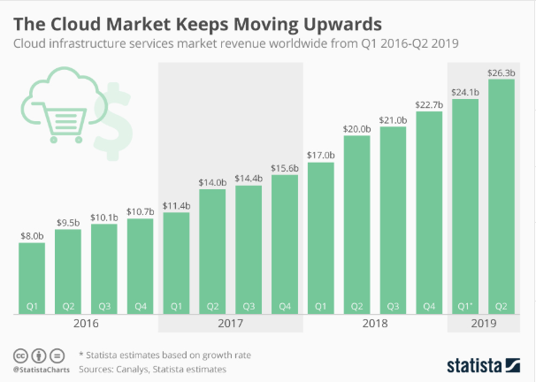

Source: Statista 2020

Businesses like healthcare, Fintech etc. are high adopters of cloud due to stricter regulations and compliance requirements to help mitigate against cyberthreats and sensitive information. It has become increasingly adopted in all industries, through public, private or a hybrid cloud environment.

Cloud computing today advanced to incorporate areas from artificial intelligence, predictive analytics, virtual software vs physical hardware. In the future we will expect an increased and enhanced execution of AI algorithms continuous integration of processes, delivery and utilization in open-source software. Big data and security will ever so evolve with new developments to keep up with advancements. In addition, cloud computing will develop to be more specialized, customizable and automated for end user experience. Developments within block chain, artificial intelligence, R&D, robotics etc. all rely on cloud technology and will advance into the future.

**What technological or other developments make this possible?**

**Storage/Data - Industry standards**

A classification system is important to provide a consistent standard and therefore provides assurance and quick adoption.

Data Centers have 4 distinctive tiers that allow businesses to align their infrastructure needs for general operation and to sustain continual growth.

The American National Standards Institute (ANSI) and Telecommunications Industry Association (TIA) published standards for data centers and you can find the complete description on their websites.

Essentially, what sets them apart are the features such as cooling, power, maintenance and recovery in times of fault. This allows companies to comply to their organizations needs with compliance, security and regulations.

* Tier 1: Basic Site Infrastructure has a single path of power and single distribution path.
* Tier 2: Redundant Capacity Component Site Infrastructure also has a single path for power and cooling with a few redundant and backup components.
* Tier 3: Concurrently Maintainable Site Infrastructure has multiple paths for power and cooling and systems with redundant capacity components and multiple independent distribution paths.
* Tier 4: Fault Tolerant Site Infrastructure is built to be completely fault tolerant and has redundancy capacity components for near all physical events.

**Virtualization developments**

The ability to run multiple operating systems on the same machine via virtualization. Allows you to do things such as run old systems, testing new software, etc. Whereby any issues that arise can be simply resolved by deleting the virtual environment as its contained.

Backups are also vital and provide snap shots, which is valuable for servers. Bandwidth across multiple VMs on your machine so it doesn’t use up your main machine. Overall, saves money and resources, no physical space and cooling, access to technological architect not existing on your machine and saves on maintenance, provisioning and recovery.

**Servers, Software and Applications**

The Market Leaders in hosting web-based applications such as Amazon Web Services (AWS), Microsoft Azure and Google Cloud platform pave the way technology advancement through software capabilities to make this possible.

AWS provides services are comprehensive through storage, messaging, computing infrastructure, content management, on demand delivery technology services as pay as you go model. Infrastructure technology to emerging technologies.

Azure is a cloud service platform to deliver global network with the ability to choose preferred tools and frameworks. Apart from infrastructure computing services It can also utilize Microsoft applications such as online Windows and Office as well as Microsoft SQL Server, Microsoft CRM, .NET services, and SharePoint services. and allows for hybrid environments.

Google Cloud provides through delivery of computing systems and infrastructure networks, users can benefit the Google platforms such as digital assistant, google cloud SQL, storage etc.

There is a huge growth and competition as these firms deliver powerful software developments in their cloud platform market and continue to do so with cutting edge advancements in intelligence such as AI, AR, IoT etc.

**What is the likely impact? (300 words) What is the potential impact of this development? What is likely to change? Which people will be most affected and how? Will this create, replace or make redundant any current jobs or technologies?**

The impact is that servers increasingly will be on cloud and services executed through these channels simply because of the added benefits listed above. Hosting software applications in a web-based cloud environment has many advantages versus being held in a private physical server or software.

There 3 types of cloud computing environments – public, vs private to hybrid. Therefore, depending on your needs you don’t have to go all public for example and host some applications or data stored through private physical servers. This gives the flexibility for firms in certain industries that have extra sensitive information that need this option.

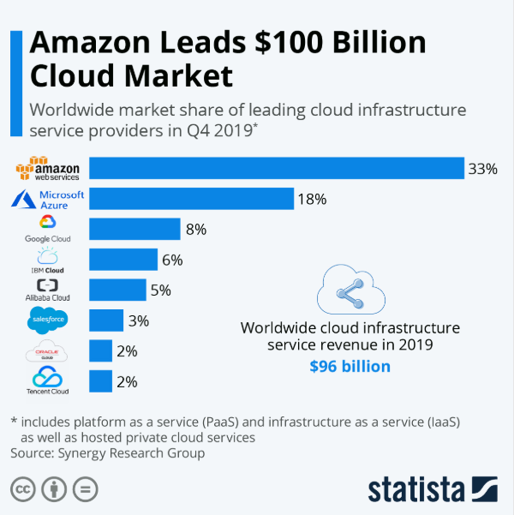

Source: Statista 2020

Across the different providers you can see the top 3 uses of cloud solutions. Amazon Web Services, Microsoft Azure and Google Cloud, take up most of the market share. Global cloud market growth to increase by 17% according to Gartner.

I believe because of efficiencies saved, that means man power in teams may decrease across different industries simply because of the cost saving and resources with AI, Augmented Reality and machine learning advancements such as online training videos which reduces face to face training, chatbot for queries and support. Firms are increasingly adopting an online, non-personal method of interaction replacing the traditional methods of a decent sized customer service to sales team. We have already seen this adoption in education centers with online learning, AR in replicating surgeries for surgeons and even such things as Siri on the iPhone.

Reformation of how we use big data to automate and digitalize processes has changed the workforce with companies investing in individuals with data science, functional language or technical skill sets. There has been an increasing need for the workforce to upskill to keep abreast of the technological advancements and to replace manual tasks to work smarter.

For the IT industry, we would see a shift to other skills sets to support the automation, predictive analytics and digitalization of the software.

Below chart illustrates the growth rate in IT by segment. "Emerging tech” includes fields like IoT software, big data/analytics, AR/VR, etc., which is expected to see the most growth, with forecasts suggesting growth in the sector by 109 percent between 2017 and 2022.

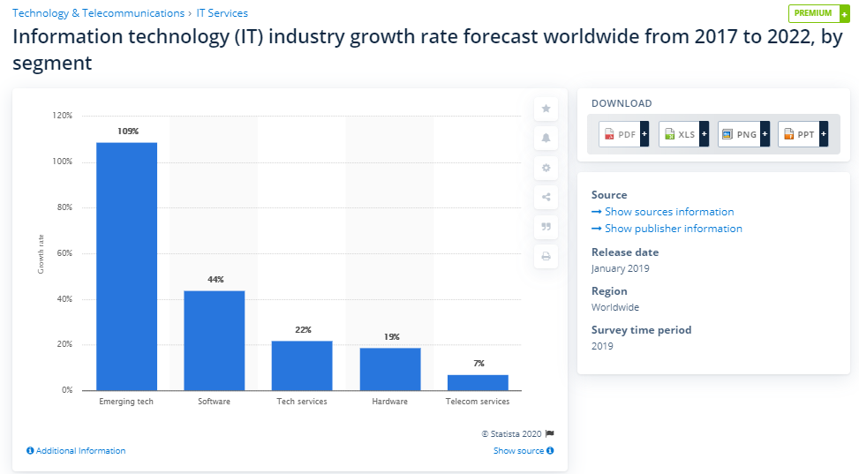

Source: Statista 2020

**How will this affect you? (300 words) In your daily life, how will this affect you? What will be different for you? How might this affect members of your family or your friends?**

In our daily lives, with clouds, services and servers advancing in technology and providing a wider range of services to the community we will see the impact in areas as below:

* AI advancements, access to storage of data etc. will be more customized and automated
* More choices by network providers
* Lower pricing packages use as you need model e.g. increase memory space etc.
* Online access anywhere for storage and backups, clouds for ease of use e.g. OneDrive, Drop Box
* Increased Security as Cybersecurity is increasingly important, banking apps etc.
* Enhanced user experience, ease of use
* Stability and Reliability
* Speed with quicker loading, streaming etc.
* Access to latest technologies, software etc.
* Gaming – scalable for gaming for streaming of big data
* Apps – accessibility to mobile friendly access and increased stability
* Connectivity to a software/hardware requiring use of big data and content
* Connectivity and sustainability for social media with the mass followers and subscribers

This has huge benefits and makes a difference for me as I will be able to use technology services hosted by powerful clouds and servers with the convenience and ease with minimal disruptions. I like the fact that everything is online and on a secure cloud, where I am assured everything is backed up. I believe AI, big data, automation will be advancing to make my everyday personal and work life customized to my preferences and change as per my usage needs.

This will equally impact my family and friends. We sometimes may not even realize we are experiencing advancements in some of these areas like in software, security etc. As our expectation standards are a lot higher than the past and its automatically part of the user experience. But we are influenced and exposed to the suggestive predictive analysis. For example, when we click on a picture, searching on a topic, any item or liking a social media post triggers related news and advertisements bringing in the commercialization aspect in this industry. Thus, understanding policies, usage and data collection is a focus as it affects our privacy. Most work places also enforce education of cybersecurity, work place policies and practices with quizzes to make us aware of such dangers and what we should do in those situations and promote best practices. This is not only useful for work but in our everyday lives when accessing software technology over the internet or even just understanding storage of our private data. Communication is so easy these days with messenger apps, video calls, who makes calls to a physical phone anymore? It’s almost all through the internet via online communication. A recent example is of Zoom, an online video call conferencing cloud based (SaaS) system that took over the market share recently, even over Microsoft Teams and Skype. The simple extra features and usability made a difference, is because of items like beautified face features, easy to use, ability to change background etc. Beside the fact of privacy issues, that have surfaced, it has still become a popular choice in the market and kept a competitive edge for now.

Overall impact of society with cloud, services and servers includes advancements in computing services through innovation, creativity, flexibility. With recent events of COVID-19 affecting us all globally currently, it is an example of how important technology is. Clouds, services and servers makes possible the delivery of these computing services. Increased internet usage across industries has seen a massive shift to online delivery of food, online purchases, entertainment and individuals and companies have needed to change the way they work and personal habits. The stability, bandwidth, agility and scalability of service providers provide us the best technologies and advancements in the future.

References

1 Azure.microsoft.com 2020. What is Cloud Computing? [online] Available at: <https://azure.microsoft.com/en-au/overview/what-is-cloud-computing/> [Accessed 13 April 2020].

2 aws.amazon.com 2020. What is Cloud Computing? [online] Available at: <https://aws.amazon.com/what-is-cloud-computing/> [Accessed 13 April 2020].

3 Statista.com 2020. The Cloud Market Keeps Moving Upwards [online] Available at: <https://www.statista.com/chart/19039/cloud-infrastructure-revenue/> [Accessed 13 April 2020].

4 IDG Communications Inc 2020. What are data centers? How they work and how they are changing in size and scope [online] Available at: <https://www.networkworld.com/article/3223692/what-is-a-data-centerhow-its-changed-and-what-you-need-to-know.html> [Accessed 13 April 2020].

5 Nlyte 2020. What Is Colocation Data Center? [online] Available at: <https://www.nlyte.com/faqs/what-is-colocation-data-center/> [Accessed 13 April 2020]

6 TIA-942 2014. About Data Centers [online] Availability at: <http://www.tia-942.org/content/162/289/About_Data_Centers> [Accessed 13 April 2020].

7 Electronic Team, Inc. 2020. Pros and cons of the virtual machines - How to access serial devices in VMs [online] Available at: <https://www.serial-server.net/virtual-machine/> [Accessed 13 April 2020].

8 The ACM 2020. The Cloud as an Innovation Platform for Software Development [online] Available at: <https://cacm.acm.org/magazines/2019/10/239669-the-cloud-as-an-innovation-platform-for-software-development/fulltext> [Accessed 13 April 2020]

9 Educba 2020. AWS vs Azure vs Google Cloud [online] Available at: <https://www.educba.com/aws-vs-azure-vs-google-cloud/> [Accessed 13 April 2020]

10 Statista.com 2020. Amazon Leads $100 Billion Cloud Market [online] Available at: < https://www.statista.com/chart/18819/worldwide-market-share-of-leading-cloud-infrastructure-service-providers//> [Accessed 13 April 2002]

11 Gartner, Inc 2020. Gartner Forecasts Worldwide Public Cloud Revenue to Grow 17% in 2020 [online] Available at: < <https://www.gartner.com/en/newsroom/press-releases/2019-11-13-gartner-forecasts-worldwide-public-cloud-revenue-to-grow-17-percent-in-2020>> [Accessed 13 April 2020]

11 Stravium Intelligence LLP 2017. How technological advancements are changing workplace training [online] Available at: <<https://www.analyticsinsight.net/how-technological-advancements-are-changing-workplace-training/>> [Accessed 13 April 2020]

12 Statista.com 2020. Information technology (IT) industry growth rate forecast worldwide from 2017 to 2022, by segment [online] Available at: <<https://www.statista.com/statistics/967095/worldwide-it-industry-growth-rate-forecast-segment/>> [Accessed 13 April 2002]